**How to pack a backpack for an adventure…**

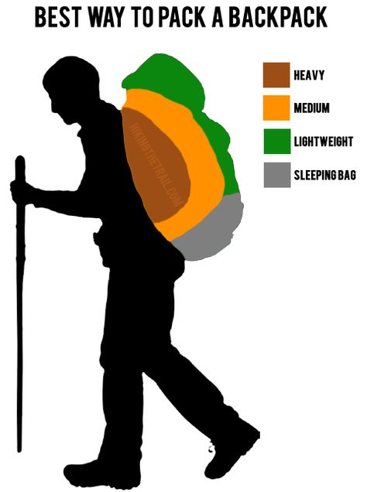***Packing Principles***

The following are common principles that you should follow when packing your backpack:

* Pack the less used, lighter gear on the bottom of the pack
  + sleeping mat, spare clothes, and sleeping bag
* Pack heavy gear close to the centre of your back
  + water, cooking equipment and the bulk of your food
* Pack the frequently used gear on top
  + wet weather gear, 1st aid kit, clothes, snacks and lunch

***Waterproofing***

The last thing you want is a wet sleeping bag or change of clothes, so yes it’s important to go overboard on the water proofing. You can use either a pack liner or durable garbage bag, make sure you use it correctly:

* + pack liners are lightweight internal bags that will protect your equipment from the heaviest of rains and to a point pack submersion.
  + The waterproof bag should be larger than the pack size so all of your belongings can be protected.
  + When pack liner is filled there should be extra room with the pack liner peeking out from the top of your pack. With that you will fold the top of the pack liner so rain and water cannot seep through. This is essential to do properly to keep your stuff dry😊

***Fitting your backpack***

A hip belt can transfer 80-90% of your backpack's weight off your shoulders and on to your hips. On a properly fitted backpack, the hip belt should rest on the top of your hip bones. Adjust your shoulder straps then tighten your hip belt. When you feel the weight come off your shoulders, you've got it. When on your back, adjust the straps so that it sits two inches below the shoulder. The pack should end at your waist and not extend past two inches above your hips

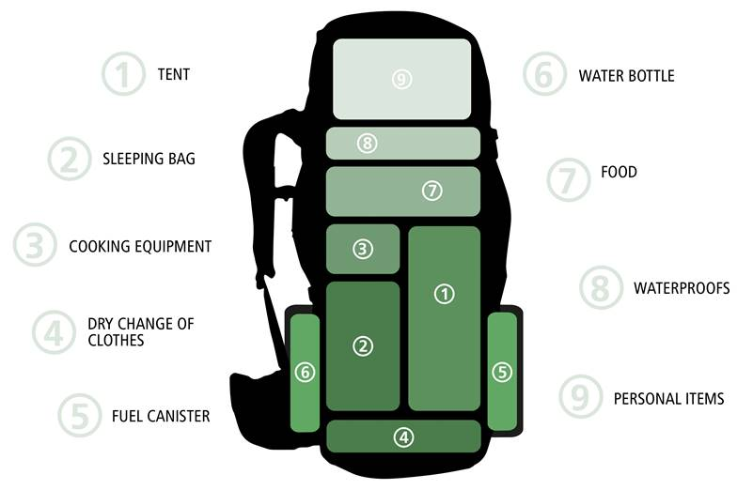

***Attaching Gear Externally***

If you have packed your backpack properly and have the right pack size, you shouldn’t need to attach much on the outside. However, sometimes it is necessary due to limited space or odd shaped items. Try to avoid doing this, however, because lashing gear to your pack could affect your balance and may also swing, rattle, or snag plants on the trail. To avoid stability issues, be sure to balance weight of items attached to your bag.

Your **backpack** shouldn't weigh more than 5-10% of your body weight.

***Lifting your pack***

* **Start low:** We encourage to bend the knees and grab the pack with both hands before slowly standing up. If the pack is especially heavy, it may help to place the pack on a table or chair or even asking your fellow friend to assist you before lifting all the way.
* **Never twist:** [Jerking](http://www.providence.org/blog/2017/03/acl-tears-on-the-rise-in-young-athletes-especially-girls) a heavy pack on or off could lead to shoulder injury and back strain. When taking off a backpack grab a friend so they can help you back up and slide the pack off.

For maximum stability, load your backpack so the heaviest equipment is next to your back and centred in the pack. Medium-weight gear should be carried toward the top and outside portion of the pack and lightweight gear, like your sleeping bag, should be packed in the bottom ( see picture above).