Duke of Edinburgh Award

The Duke of Edinburgh’s International Award comprised of three levels each progressively more challenging:

Bronze (minimum 1 night campout)

Silver (mimimum 2 night campout)

Gold (minimum 3 night campout)

Participants are required to complete four sections at each level: Voluntary Service, Skill, Physical Recreation and Adventurous Journey.

The journey can be an exploration or an expedition but must be a challenge. The aim of this Section is to provide participants with the opportunity to learn more about the wider environment, as well as to develop their self-confidence, teamwork and health. Participants are taken out of their comfort zone- in an unfamiliar environment but kept within a safe and secure setting, achieved through suitable training and supervision.

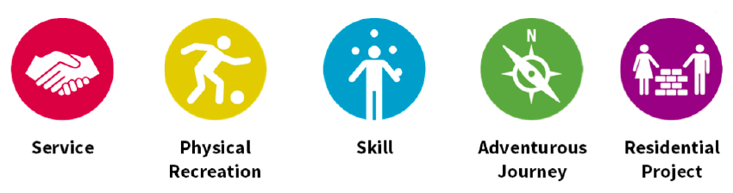

Suggested Food for DOE Program

Breakfast
- Breakfast Bars (take our of box and carry seperatly)
  - Oats (individual portions)
  - Dried fruit
  - Cereal
- Hot drinks
  - Coffee, Hot Chocolate or Tea with powered milk
- Hot Food
  - Porridge, Custard, Boil in the bag meal
Handy Hint! – remove unneeded packaging from your food before you pack it, saving space and weight.
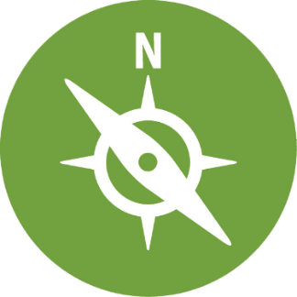
Although seen as an easy meal- up and go style drinks add a lot of weight to your pack and are full of sugar that you burn up fast (not long lasting.) Best to have a solid breakfast to give you the energy that you require for all the activities during the day.

Lunch
- Sandwiches or Wraps
- Tuna or pasta lunch kit (found in the supermarket)
- Savoury Snacks
  - Crackers, Cheese, Crisps
- Sweet Treats
  - Cake
  - Fresh fruit
  - Chocolate
Handy Hint! – You will be out in the wilderness for lunch so make sure its quick and easy to prepare with minimal rubbish.

Dinner
- Ready to Eat Meals
  - Freeze Dried Meals (just add hot water)
  - Boil in the Bag (use the trangia to heat it up)
- One Pot Meals…
  - Pasta or rice
  - Sauce (Most supermarkets have a stir and serve sauce that will make your mealtimes quick & easy)
  - Cured meats like chorizo or salami add loads of flavour and texture- make sure they are vacuumed packed
Handy hint! 2 minute noodles are a quick meal to prepare. Add some meat and/or vegetables to make it a filling meal and give you energy

Dessert
- Fruit salad pots
- Cake and Custard
- Hot drink
- Sweet biscuits
Handy Hint! – Why not try bringing your food already divided into individual meal portions. Saving prep time in camp and helping you keep your bag organised.

Suggested clothing for DOE Programs

CLOTHING
- 1 pair of walking boots (broken in)
- walking socks (one for each day)
- 2-3 t-shirts
- Thermal t-shirt (optional)
- 2 fleece tops (preferable not cotton as it takes a long time to dry if it gets wet)
- 2 walking trousers (not jeans as they can cause chaffing especially while wearing a pack)
- Underwear (pair for each day)
- Nightwear (can wear thermals)
- Trainers or closed toe sandals (to wear at campsite to rest feet from hiking boots)
- Sunhat (wide brim for sun protection)
- 1 pair gloves
- 1 pair shorts (if appropriate)
- Waterproof over-trousers (if appropriate)
- Jacket/coat (waterproof & windproof)
- 1 pair gaiters (optional)

PERSONAL KIT
- Sleeping bag
- Waterproof compression stuff sack (5/10/15 litre)
- Whistle
- Head torch with spare batteries
- Personal first aid kit
- Expedition food (including emergency rations)
- Water bottle (3 x 1L bottles, unless otherwise advised)
- Knife, fork, spoon or Spork
- Plate/bowl
- Tea towel
- Mug/ cup
- Box of matches (in waterproof container)
- Wash kit/personal hygiene items
- Towel
- Notebook and pen/pencil
- Watch
- Sunglasses
- Sunscreen
- Insect repellent
- Spare boot laces

